**Project Design Phase**

**Solution Architecture**

|  |  |
| --- | --- |
| Date | 20 june 2025 |
| Team ID | LTVIP2025TMID32074 |
| Project Name | Sustainable Smart City using IBM Granite |
| Maximum Marks | 4 Marks |

**Solution Architecture**

**The solution architecture for the Sustainable Smart City Assistant bridges the gap between the complex needs of urban sustainability and modern AI-based solutions. The main objectives of this architecture are to:**

* **Identify the best cloud-based and AI-driven technologies to support smart city goals.**
* **Clearly define how the components (chat assistant, eco-tips, city health dashboards, etc.) interact with each other.**
* **Establish a modular structure for scalability, flexibility, and ease of updates.**
* **Describe the interaction between users (citizens/admins), backend services, Hugging Face API, and data sources.**
* **Ensure real-time response capabilities using FastAPI and an intuitive frontend using Streamlit.**

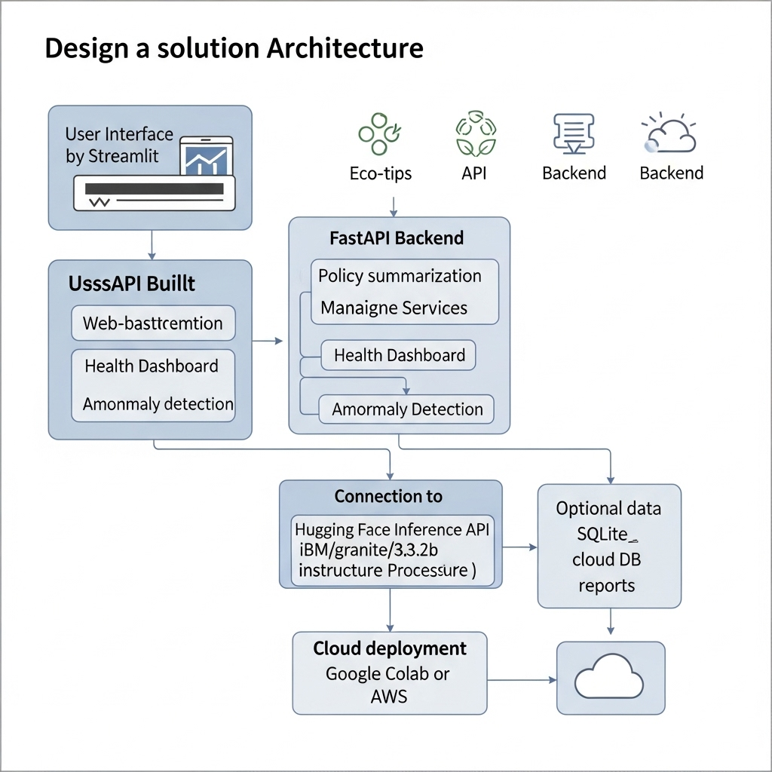

**Solution Features & Flow**

* **Frontend: Developed in Streamlit, provides a user-friendly chat interface for citizens and administrators to interact with various modules.**
* **Backend: Built with FastAPI, handles modular services like eco-advice, health indicators, summarization, and citizen reports.**
* **Model Inference: Uses Hugging Face Inference API (e.g., google/gemma-2b-it) to process natural language queries and return contextual answers.**
* **Data Storage (Optional): Can integrate with cloud-based storage or a local SQLite/PostgreSQL database for logs or metadata.**
* **Deployment: Can be hosted on cloud platforms like AWS, GCP, or in Google Colab for prototyping.**